**Joseph Tierney**

**Computer Science 1B**

**Computer Programming Assignment**

**Contents**

1. **Introduction**
2. **Steps**
3. **Program Walkthrough**
4. **Test Bed**
5. **Conclusion/Evaluation**

**Introduction**

The program is required to enter Leaving Cert grades for two students and calculate the points each achieved. The user is asked to enter each student’s name and enter seven grades for each student. A while loop will be used for one student, and a for loop will be used for the other. The total points will be calculated by using the best six grades, the lowest grade will not be used in the points calculation. The program will then tell the user the highest, lowest and average number of points for each student, as well as telling the user the name of the student that got the highest points score, or if both students got the same amount of points.

**Steps**

1. Import Scanner
2. Start Class
3. Start Main Method
4. Declare Variables
5. Prompt the user for first students name
6. While Loop to take in first set of grades
   1. Prompt user to enter grades
   2. Use an if statement to set the highest points achieved
   3. Assign point values using if statement
   4. Use an if statement to set the lowest points achieved
   5. Set lowest value after every points achieved
   6. Use else if for the remaining point values
   7. Use else for last point value
   8. Calculate the total points for student1
   9. Increment i
   10. End While Loop
7. Prompt user for second students name
8. Use “if(!=1)” to use input.nextLine();
9. For Loop to take in second set of grades
   1. Prompt user to enter grades
   2. Use an if statement to set the highest points achieved
   3. Assign point values using if statement
   4. Use an if statement to set the lowest points achieved
   5. Set lowest value after every points achieved
   6. Use else if for the remaining point values
   7. Use else for last point value
   8. Calculate total points for student2
   9. End For Loop
10. Remove the lowest score from each total
11. Calculate the average for each student
12. Print the results for the first student
13. Print the results for the second student
14. If statement to determine which student got the highest amount of points
15. Print the results
16. End main method
17. End class

**Program Walkthrough**

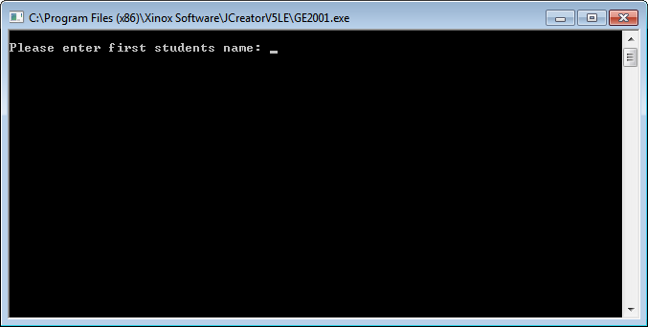

The program starts by prompting the user to enter the first students name.

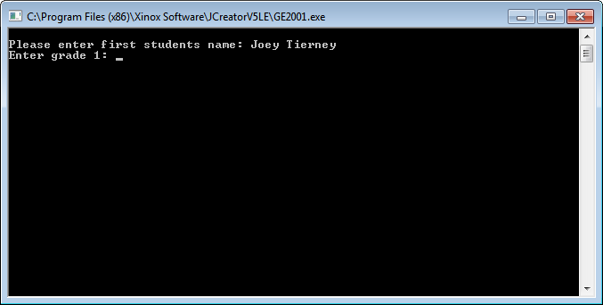

The user is then asked to enter the first grade that student one received.

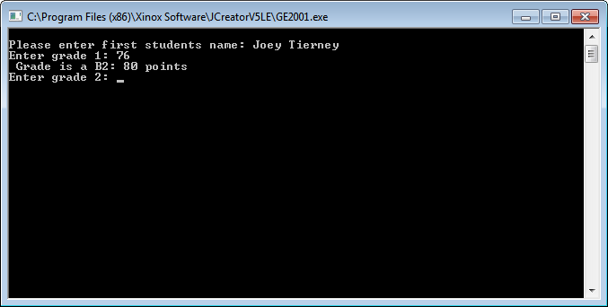

When the first grade is entered, the points of that grade are printed, and the user is asked to enter the remaining six grades.

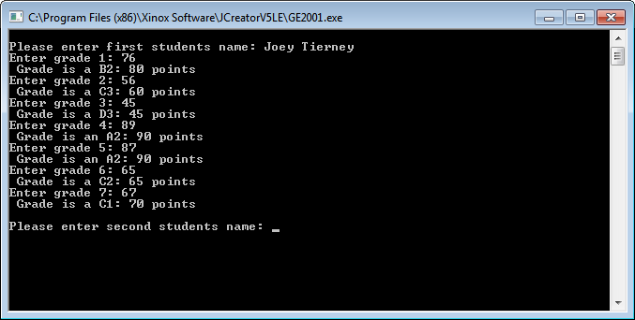

When all grades for the first student have been entered, the user is asked for the second students name.

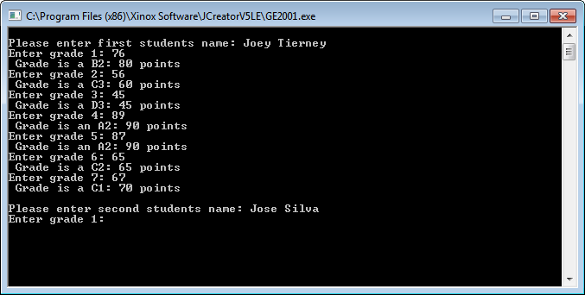

The user is then asked to enter the first grade that student two received.

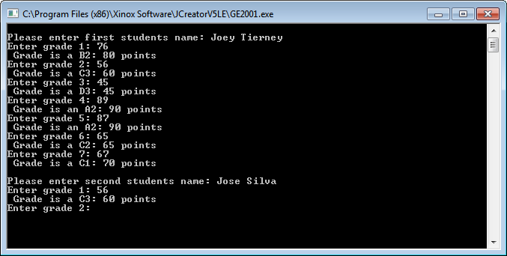

When the first grade is entered, the points of that grade are printed, and the user is asked to enter the remaining six grades.

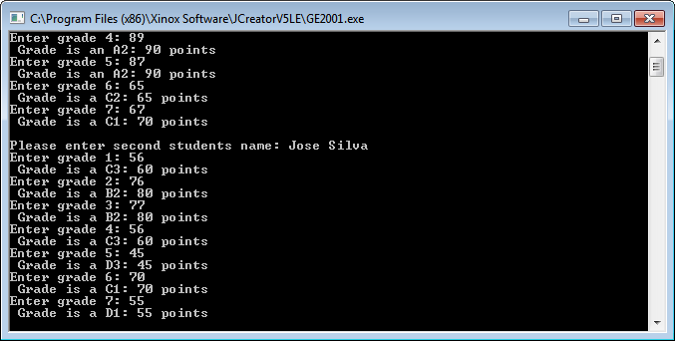

The remaining grades are printed for student 2.

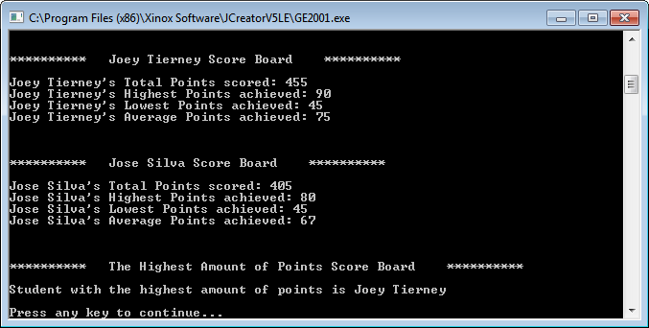

In the final result, both students total points, highest points, lowest points and average points are printed, as well as the student who got the highest amount of points between the two.

**Test Bed**

|  |  |  |  |
| --- | --- | --- | --- |
| **Scenario** | **Data Entered** | **Expected Result** | **Actual Result** |
| Enter name of student 1 | Joey Tierney | Enter Grade 1 | Enter Grade 1 |
| Enter Grade 1 | 76 | Enter Grade 2 | Enter Grade 2 |
| Enter Grade 2 | 56 | Enter Grade 3 | Enter Grade 3 |
| Enter Grade 7 | 67 | Enter name of student 2 | Enter name of student 2 |
| Enter name of student 2 | Jose Silva | Enter Grade 1 | Enter Grade 1 |
| Enter Grade 1 | 56 | Enter Grade 2 | Enter Grade 2 |
| Enter Grade 2 | 76 | Enter Grade 3 | Enter Grade 3 |
| Enter Grade 7 | 55 | Results | Results |
|  |  |  |  |

**Conclusion/Evaluation**

The program works as required by the brief. The part of this assignment I had the most difficulty with was finding a way to assign the lowest value points to take away from the total. At the beginning, my program would only take away the 7th grade entered, no matter what the value was, this was fixed by assigning the lowest value in the if statements themselves instead of assigning them outside. The final testing displayed in the test bed results match perfectly with what my program is intended to do.

If I were to start the assignment again, or I had more time to work on it, I would make entering a value larger than 100 for the program to tell the user that the amount they’ve entered is an invalid number, and to re-enter it. I think that this could be done to make the program better overall.

In conclusion, I am satisfied with how the program has turned out.